library(readr)

## Warning: package 'readr' was built under R version 4.1.2

LeafWidth <- read_csv("LeafWidth.csv")

## Rows: 252 Columns: 5  
## ── Column specification ────────────────────────────────────────────────────────  
## Delimiter: ","  
## dbl (5): Width, Length, length-to-width ratio, Area, Year  
##   
## ℹ Use `spec()` to retrieve the full column specification for this data.  
## ℹ Specify the column types or set `show_col_types = FALSE` to quiet this message.

attach(LeafWidth)

head(LeafWidth)

## # A tibble: 6 × 5  
## Width Length `length-to-width ratio` Area Year  
## <dbl> <dbl> <dbl> <dbl> <dbl>  
## 1 0.658 85.1 129. 70.3 1974  
## 2 0.921 53.2 57.7 49.0 1918  
## 3 0.921 59.9 65 57.7 1993  
## 4 0.921 63.7 69.1 37.4 1946  
## 5 0.921 64.2 69.7 62.6 1956  
## 6 0.921 87.0 94.4 67.5 1964

plot(Width~Year)  
model = lm(Width~Year)  
abline(model)

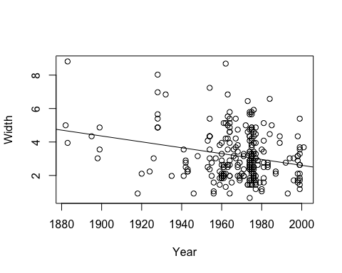

cor(Width, Year)

## [1] -0.2469483

cor.test(Width, Year)

##   
## Pearson's product-moment correlation  
##   
## data: Width and Year  
## t = -4.0294, df = 250, p-value = 7.425e-05  
## alternative hypothesis: true correlation is not equal to 0  
## 95 percent confidence interval:  
## -0.3595491 -0.1272589  
## sample estimates:  
## cor   
## -0.2469483

summary(model)

##   
## Call:  
## lm(formula = Width ~ Year)  
##   
## Residuals:  
## Min 1Q Median 3Q Max   
## -3.1214 -1.1253 -0.3136 0.9320 5.4144   
##   
## Coefficients:  
## Estimate Std. Error t value Pr(>|t|)   
## (Intercept) 37.723091 8.574977 4.399 1.61e-05 ***  
## Year -0.017560 0.004358 -4.029 7.43e-05 ***  
## ---  
## Signif. codes: 0 '***' 0.001 '**' 0.01 '*' 0.05 '.' 0.1 ' ' 1  
##   
## Residual standard error: 1.424 on 250 degrees of freedom  
## Multiple R-squared: 0.06098, Adjusted R-squared: 0.05723   
## F-statistic: 16.24 on 1 and 250 DF, p-value: 7.425e-05

anova(model)

## Analysis of Variance Table  
##   
## Response: Width  
## Df Sum Sq Mean Sq F value Pr(>F)   
## Year 1 32.91 32.911 16.236 7.425e-05 ***  
## Residuals 250 506.76 2.027   
## ---  
## Signif. codes: 0 '***' 0.001 '**' 0.01 '*' 0.05 '.' 0.1 ' ' 1

Caterpillar <- read_csv("Caterpillar.csv")

## Rows: 267 Columns: 12  
## ── Column specification ────────────────────────────────────────────────────────  
## Delimiter: ","  
## chr (3): ActiveFeeding, Fgp, Mgp  
## dbl (9): Instar, Mass, LogMass, Intake, WetFrass, DryFrass, Cassim, Nfrass, ...  
##   
## ℹ Use `spec()` to retrieve the full column specification for this data.  
## ℹ Specify the column types or set `show_col_types = FALSE` to quiet this message.

attach(Caterpillar)  
head(Caterpillar)

## # A tibble: 6 × 12  
## Instar ActiveFeeding Fgp Mgp Mass LogMass Intake WetFr…¹ DryFr…² Cassim  
## <dbl> <chr> <chr> <chr> <dbl> <dbl> <dbl> <dbl> <dbl> <dbl>  
## 1 1 Y Y Y 0.00206 -2.69 0.165 2.41e-4 2.08e-4 0.0142  
## 2 1 Y N N 0.00519 -2.28 0.201 6.3 e-5 6.1 e-5 0.0174  
## 3 2 N Y N 0.00560 -2.25 0.189 1.40e-3 9.69e-4 0.0164  
## 4 2 Y N N 0.0193 -1.71 0.283 2.04e-3 1.83e-3 0.0239  
## 5 2 N Y Y 0.0293 -1.53 0.260 5.38e-3 3.52e-3 0.0212  
## 6 3 Y Y N 0.0626 -1.20 0.328 2.95e-2 7.89e-4 0.0284  
## # … with 2 more variables: Nfrass <dbl>, Nassim <dbl>, and abbreviated variable  
## # names ¹​WetFrass, ²​DryFrass

plot(Mass~Intake)

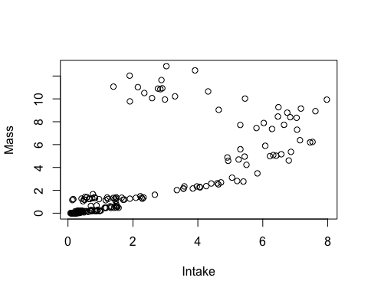

model = lm(Mass~Intake)  
plot(model)

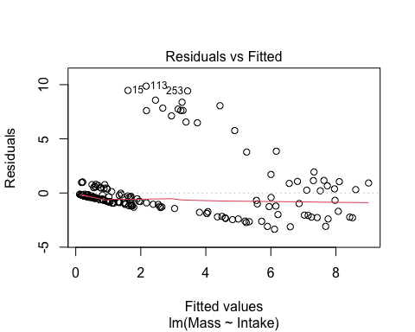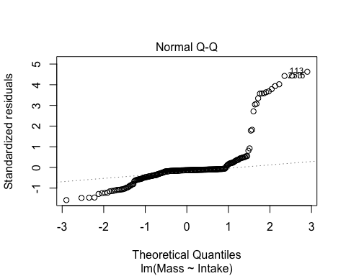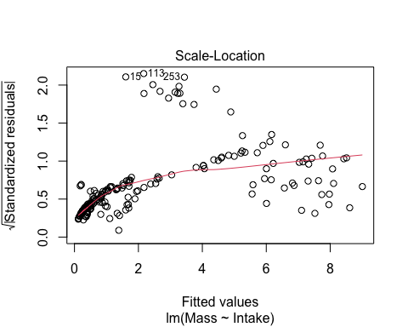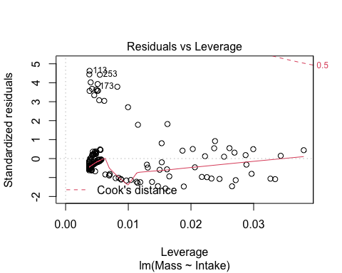

plot(log(Mass)~log(Intake))

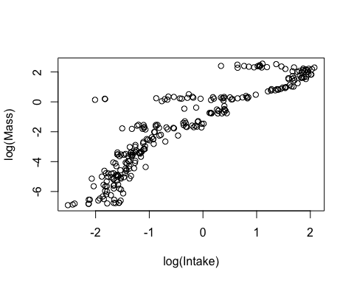

model = lm(log(Mass)~log(Intake))  
plot(model)

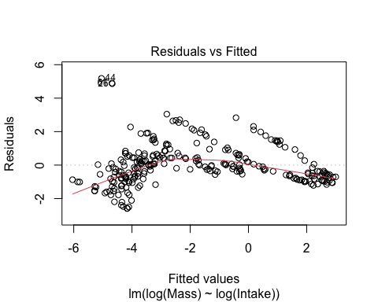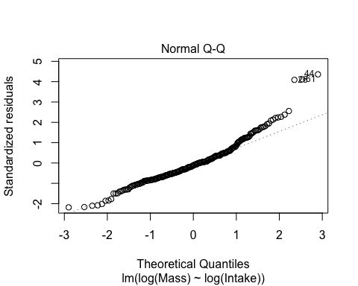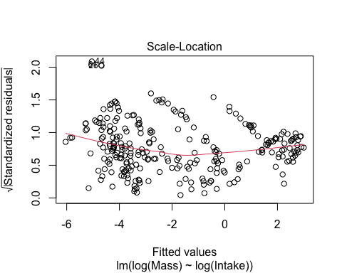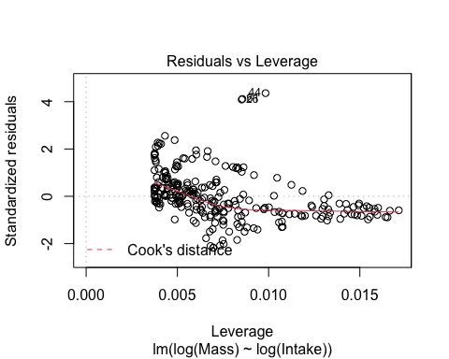

summary(model)

##   
## Call:  
## lm(formula = log(Mass) ~ log(Intake))  
##   
## Residuals:  
## Min 1Q Median 3Q Max   
## -2.5960 -0.7637 -0.1388 0.5524 5.1826   
##   
## Coefficients:  
## Estimate Std. Error t value Pr(>|t|)   
## (Intercept) -1.08922 0.07596 -14.34 <2e-16 ***  
## log(Intake) 1.96850 0.05663 34.76 <2e-16 ***  
## ---  
## Signif. codes: 0 '***' 0.001 '**' 0.01 '*' 0.05 '.' 0.1 ' ' 1  
##   
## Residual standard error: 1.194 on 265 degrees of freedom  
## Multiple R-squared: 0.8201, Adjusted R-squared: 0.8195   
## F-statistic: 1208 on 1 and 265 DF, p-value: < 2.2e-16